Everywhere Horizon of Krayon wins the GPHG 2018 Innovation watch prize

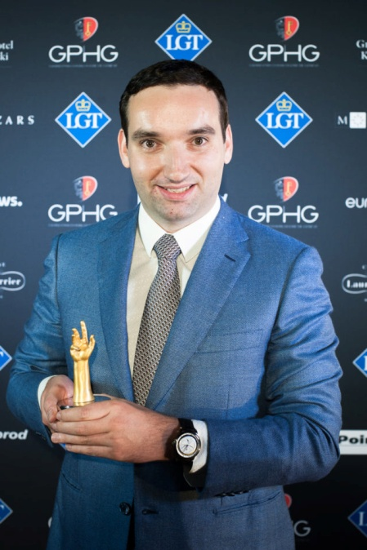

On November 9th 2018 in Geneva, in front of an audience composed of leading personalities and representatives of the Swiss watch industry, the 2018 Grand Prix d’Horlogerie de Genève unveiled its prize list, including the Innovation Watch Prize awarded to Krayon for its Everywhere Horizon. A fitting reward for an ingenious complication watch that calculates sunrise and sunset times everywhere.

"Until now, in watchmaking, this function had to be set for a specific point on earth. I decided to take a direction that no-one had explored before, and develop this purpose-built, integrated movement," says Rémi Maillat, founder of Krayon.
"The idea behind this timepiece is that anyone, anywhere in the world, can know the exact time at which they can contemplate these spectacles of nature and life."
"Because it's the work of an engineer, it appears to be a very mathematical, scientific watch when it's really something quite romantic," he added.

Everywhere Horizon in short
After the presentation in May 2017 of the first Everywhere watch, Rémi Maillat presented in 2018 a new custom timepiece, Everywhere Horizon. On land and at sea, the path of the sun across the sky underpins the notion of time and is even a way to measure its passing. Krayon's engineers nurtured their dream to be able to know sunrise and sunset times at any point on the globe, thanks to a mechanical movement. By making this dream reality, they have achieved something totally unprecedented in watchmaking: a universal mechanical calculator that gives the exact sunrise and sunset times.
Everywhere Horizon reaches this seemingly simple result by combining the four parameters that influence sunrise and sunset calculations. First latitude and longitude, which geographically define a point on Earth, then the UTC time zone, and lastly the date and month. The watch's wearer sets each one as required to then see the precise hour at which the sun will appear and disappear, in the place of his choice and on the day he wishes.
Hours are read from the outer dial thanks to a blue arrow on a 24-hour scale. Minutes are shown by a large central hand. A subsidiary dial in the upper part of the main dial displays longitude between +180° and -180°, shown by the longest of the two hands. The shorter hand points to the UTC time zone and advances in half increments to take into account every time zone in use around the world. The DST (Daylight Saving Time) indication reminds how to adjust for summer time. Two hands occupy the centre of the main dial: the one on the left covers latitude between 60°North and 60°South while the hand on the right shows the chosen parameter: date, latitude, longitude or UTC. A subdial in the lower portion of the dial presents date and month.
The finishing and decoration of Everywhere Horizon are entirely by hand, in keeping with traditional haute horlogerie techniques

Link of the press release

