Media Release  
17 November 2022

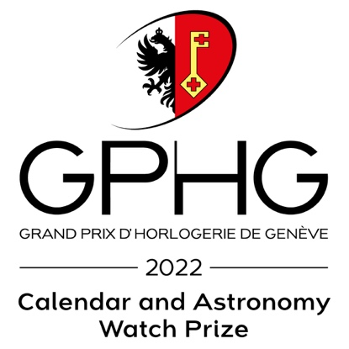

**GPHG 2022: Krayon’s *Anywhere* watch**

**wins the Calendar and Astronomy Prize**

Four years after winning the Innovation Prize at the 2018 GPHG for its first creation, *Everywhere*, Krayon wins the Calendar and Astronomy Prize at this year’s edition of the *Grand Prix d’Horlogerie de Genève* for its second masterpiece, *Anywhere*.

**An unprecedented complication:** What if it were possible to know the exact time of sunrise and sunset at a specific location chosen by You. Wherever you happen to be – or imagine yourself to be. Anywhere on the planet. *Anywhere* is the timepiece that indicates the length of the day and the time of sunrise and sunset, wherever you choose to be on Earth. A first in watchmaking.

*Anywhere* is **a bespoke ephemeris** created by Rémi Maillat, an engineer and a watch designer, and the founder of Krayon. *Anywhere* tells the time of our intimate relationship with Earth. Because there is no place more important than yours, the one you envision, the one in a fond memory, the one in your heart.

**The watch that takes *Anywhere* further,**

***Anywhere Métiers d'Art Azur* by Krayon.**

An ideal of both serene artistry and technical sophistication with its 432 components, its exceptional dial blends engineering prowess and contemporary artistic inspiration.

With this particular piece, Krayon exemplifies its commitment to preserving the high level of craftsmanship that for more than four centuries has defined watchmaking and timepiece decoration through the mastery of technique, materials and *savoir-faire*.

**A sublimely exceptional dial that merges engineering prowess and contemporary artistic inspiration.**

Is it not by cultivating ancestral techniques, by reinterpreting them with a contemporary vision, that we ensure their future?

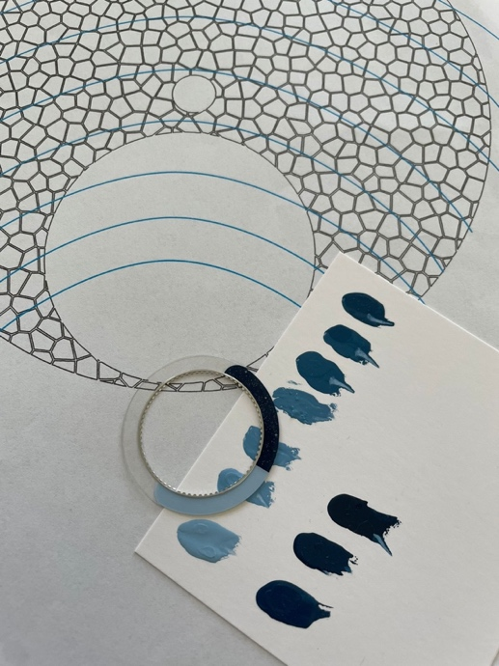



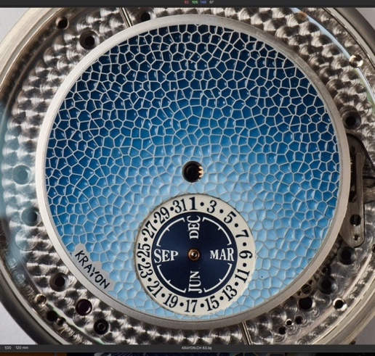Blue as an invitation to discover and explore, like the sky and ocean, infinite horizons, peace, serenity.

A tribute to the *métiers d’art*, the professions that elevate craftsmanship to an art form, the outward appearance of *Anywhere Métiers d'Art Azur* is intimately intertwined with the idea of discovery and an inner journey. In choosing the tonalities of a multitude of blues, the color itself amplifies the intention of *Anywhere*, like an invitation to contemplation, before the sun rises. That magical moment when nature, in limbo, awaits the light.

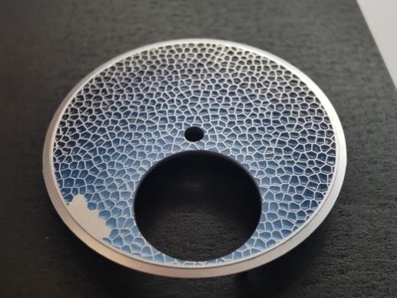If the ingenuousness of the hyper-complication in this watch, a bespoke ephemeris intimately linked to its wearer, pushes the boundaries of watchmaking, the *finesse* of its dial, playing with color in infinite hues of blue, is a respectful bow to the **centuries-old techniques of miniature painting** as practiced by master enamellers of a past age. Hollowed out of the precious metal, a multitude of small cells into which a Swiss enameling artist has patiently applied each infinitesimal droplet of lacquer by hand, creating a gradient of the desired shades of blue to obtain a result of mesmerizing refinement.



A hint of the mysterious cosmos during nocturnal hours, azure disc with a shining sun in daytime; a personal journey left to the imagination.

A sublimated dial, merging age-old mastery and modern inspiration; the harmonious curves of the case echoing the contemporary harmony of the whole; a watch that is one of its kind.

An elegant timepiece in **950 platinum,** which again demonstrates, with a degree of hand finishing elevated to an exceptional level, all the *savoir-faire* embodied by independent Swiss watchmaker Krayon; a watch to captivate and delight collectors and lovers of refinements that have become so rare.

***The complete press kit for “Anywhere Métiers d'Art Azur” is available via this link:*** [***https://www.krayon.ch/press/pr-09-anywhere-ma22/pr-krayon-metiers-art.zip***](https://www.krayon.ch/press/pr-09-anywhere-ma22/pr-krayon-metiers-art.zip)

**Press Relations Contact**

289 Consulting

Aude Campanelli – T +41 78 637 16 91

[aude.campanelli@289consulting.com](mailto:aude.campanelli@289consulting.com)